TBW-01 – Affiliate Promotional Pack

Option A: Add your affiliate link to a short description of the e-book

As an affiliate, the most basic way to promote this e-book is to simply add your affiliate link to the e-book’s title, or a brief description. For example:

NEW Napoleonic Wargaming e-book “The Battle of Waterloo: French Army 15 mm Miniature Flags - Quantity 150”

The way you add your affiliate link, is to:
- Add a hyperlink to the e-book title wording you want to use.
- Type in your unique affiliate link (double check that you have copied + pasted the entire link).
- Your link will look something like this:
- You will then have a live link to the eBook, which you can then place anywhere you want to in order to generate interest.

____________________________________________________________________________

Option B:

Add your affiliate link to a full description of the eBook + image

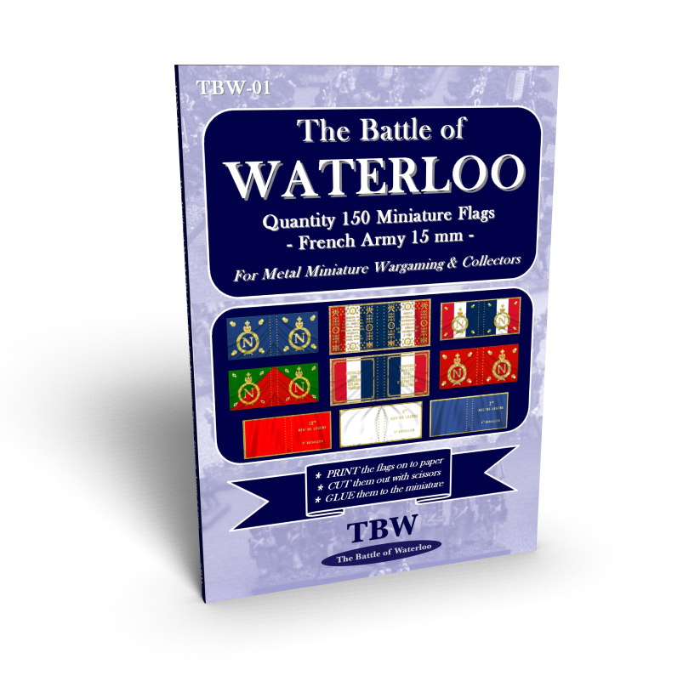
Depending on how much space you have, or wish to dedicate to promoting the e-book, you could also use the entire description, or an edited version, including a picture of the book:

The Battle of Waterloo: French Army 15 mm Miniature Flags - Quantity 150
Description
"The Battle of Waterloo: French Army 15 mm Miniature Flags" e-book, is specifically suited for collectors and wargamers who require accurate, detailed, 15mm to 18mm scale flags, for the Napoleonic French Army that fought at Waterloo in 1815.
This unique set features 150 miniature flags that are designed and arranged to be printed out on to paper, cut out with scissors, and then glued to metal miniatures. All the flags have been sized to fit 15 mm figures (Minifigs) and 18 mm (AB Figures).
Features:
* Regimental tricolour flags for all the infantry & cavalry regiments of the Line and Imperial Guard.
* Middle and Young Guard Flag/fanion variations to choose from.
* Flags/fanions for the 2-4th battalions of line infantry.
* Natural-looking folds and creases for each flag.
If your aim is to build a miniature 15/18mm scale French Waterloo army and you and you want a complete and realistic selection of flags to pick from that you can print out yourself, this selection is ideal.
"Very good quality product. Really nice professionally made set of flags. Came with notes about the flags, which was a nice touch." - Richard, Dalkeith, United Kingdom
More details/Buy Now: [<< ADD your affiliate link to whatever words you use here]

__________________________________________________________________________________

Option C: Add your affiliate link to an advertising banner!
Commonly seen on websites and blogs to advertise products and services, a colourful banner may be a preferred solution to attract interest and sales. Once your affiliate link is added, it is a simple matter for people to click on the banner if the e-book interests them.
This page will be updated with some banners, as soon as some good people demand it!
Let us know!

tbwaterloo@protonmail.com
https://www.thebattleofwaterloo.com

